TFS #99093

Deleting and reentering new addresses on location panel causes hard Error

Overview

When a new address is added and then deleted and replaced by another new address on the location panel, a hard error is triggered – “Hard Error 50935 Submit Exception – CollateralAnalysisSaveToEmpower”

April Beston

11/18/2016

Table of Contents

TFS #99093 1

Description 2

Testing Notes 3

Screen Shots and Steps Taken 3

# Description

11/16/16 KPG - INC0202787, INC0202867, INC0202599, INC0203065 - Users are receiving a hard error as they apply to EmPower after deleting an address from the Location panel for Real Estate. [See video here.](https://extranet.financialpartners.com/Workspaces/Shared/cwenhance/FPIDocuments/2016%20Q4%20TFS%20Testing%20Docs/Delete%20Errorrwmv.wmv)

Error:

Hard Error 50935 Submit Exception - CollateralAnalysisSaveToEmpower() - CommitmentActionOID - 30E6617299-3528-467C-B829-386E606DD84D  :- Unexpected SQL error occurred in uspDeletetblAddress (#547) The DELETE statement conflicted with the REFERENCE constraint 'FK_tblCollateralLocations_tblAddress". The conflict occurred in database "EMPOWER", table "dbo.tblCollateralLocations", Column 'AddressOID'. The statement has been terminated.

Steps to recreate:

1. Open the location panel

2. Add a new address

3. Delete your new address

4. Add another new address

5. Fill that one out

6. Close the location panel

7. Submit to EmPOWER

# Testing Notes

Test passed – fix deployed to QA on 11/17/16 appears to have corrected this error. See: [Video](https://mysite.financialpartners.com/my/bestona/Shared%20Documents/AgC%20Test%202.wmv)

## Screen Shots and Steps Taken

1. Add a new address on the location panel of a piece of real estate

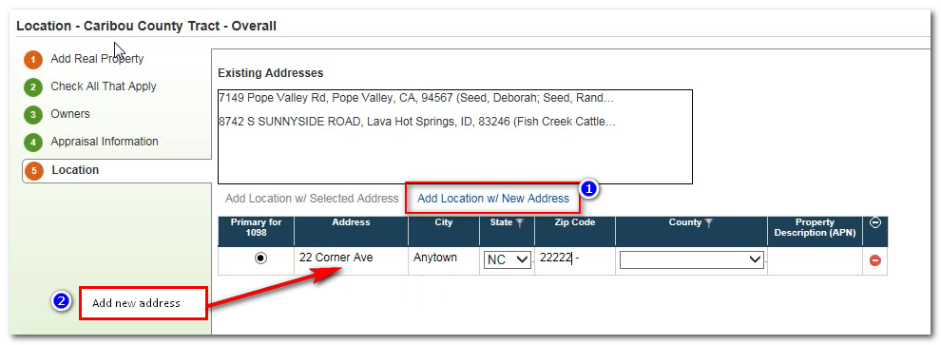

1. Delete the new address entered

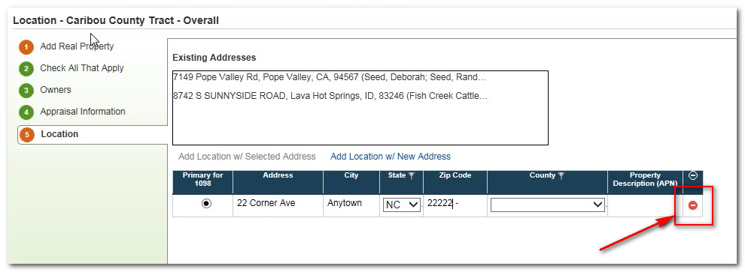

1. Enter another new address

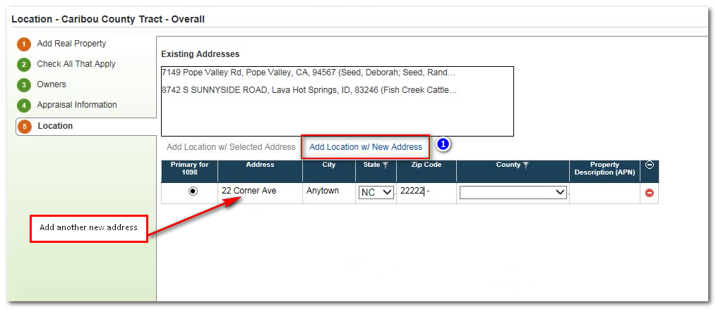

1. Submit scenario, and continue past any soft errors. Prior to fix the following hard error was triggered – this error no longer occurs.

